gara ruta

I:\UNIAC4\Installer\UNA.MD\install_una
CoreFiles должны быть установлены из данной директории (правами администратора).
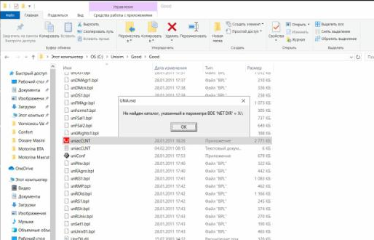
При появлении проблемы с директорией BDE необходимо указать в обозревателе каталог на диске С:\ и нажать ок.

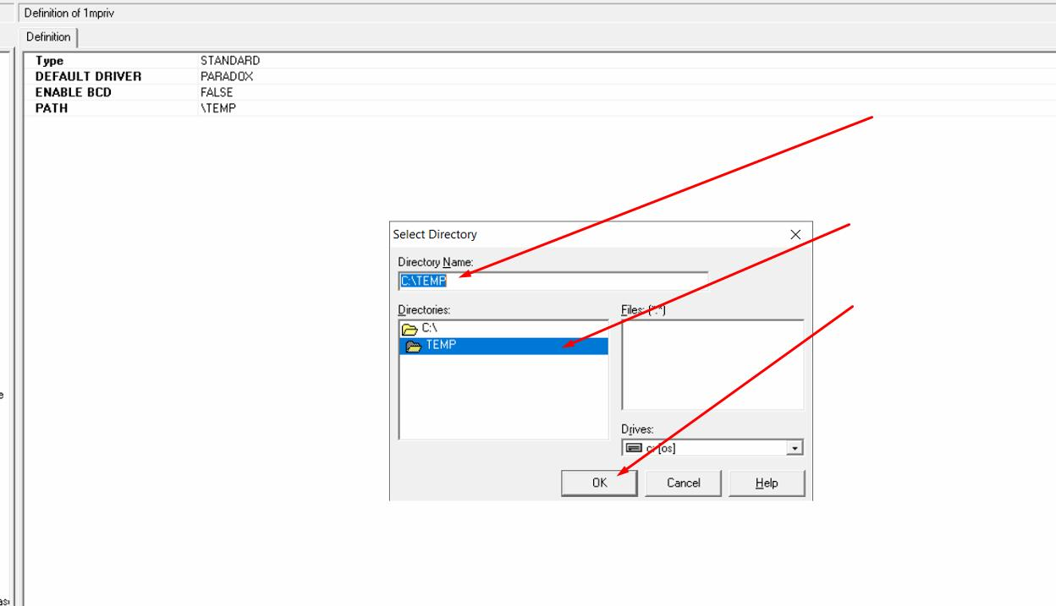

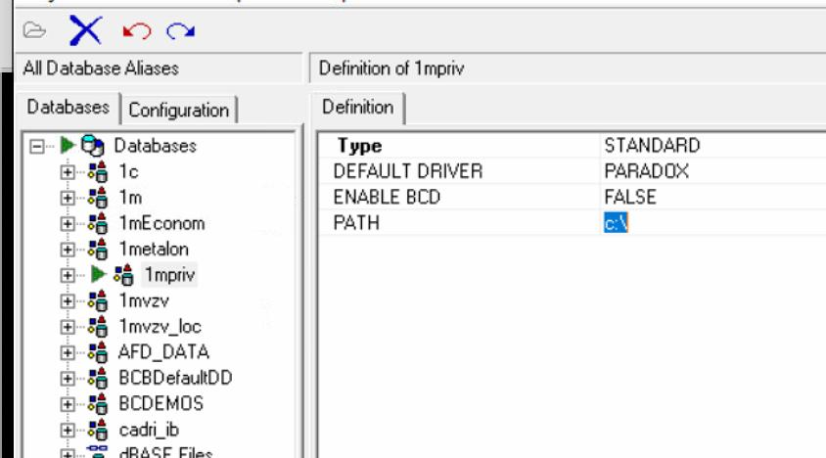
для получения доступа оĸ всему

t0users

t0computers
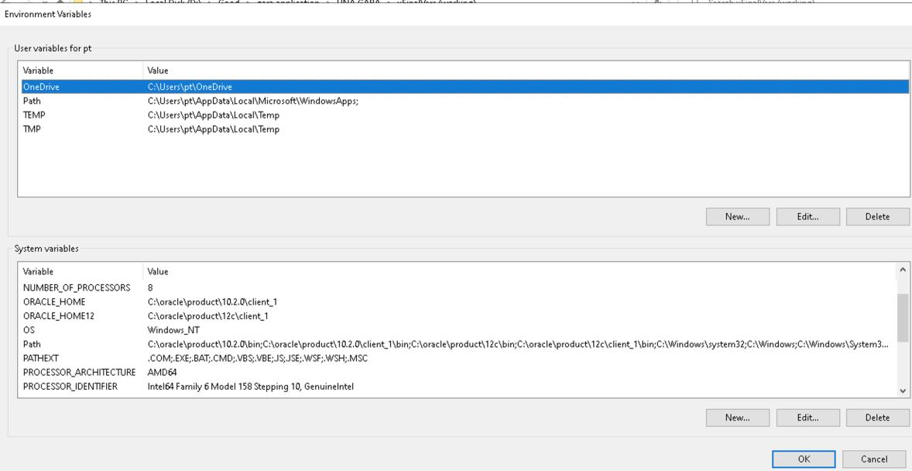

tnsping gara

C:\Users\pt>tnsping gara

TNS Ping Utility for 32-bit Windows: Version 10.2.0.3.0 - Production on 24-

AUG-2020 16:47:27

Copyright (c) 1997, 2006, Oracle. All rights reserved.

Used parameter files:

C:\oracle\product\10.2.0\client_1\network\admin\sqlnet.ora

Used TNSNAMES adapter to resolve the alias

Attempting to contact (DESCRIPTION = (ADDRESS = (PROTOCOL = TCP) (HOST = 192.168.0.24)(PORT = 1521)) (CONNECT_DATA = (SERVER = DEDICATED) (SERVICE_NAME = cloudbd.world))) OK (0 msec)
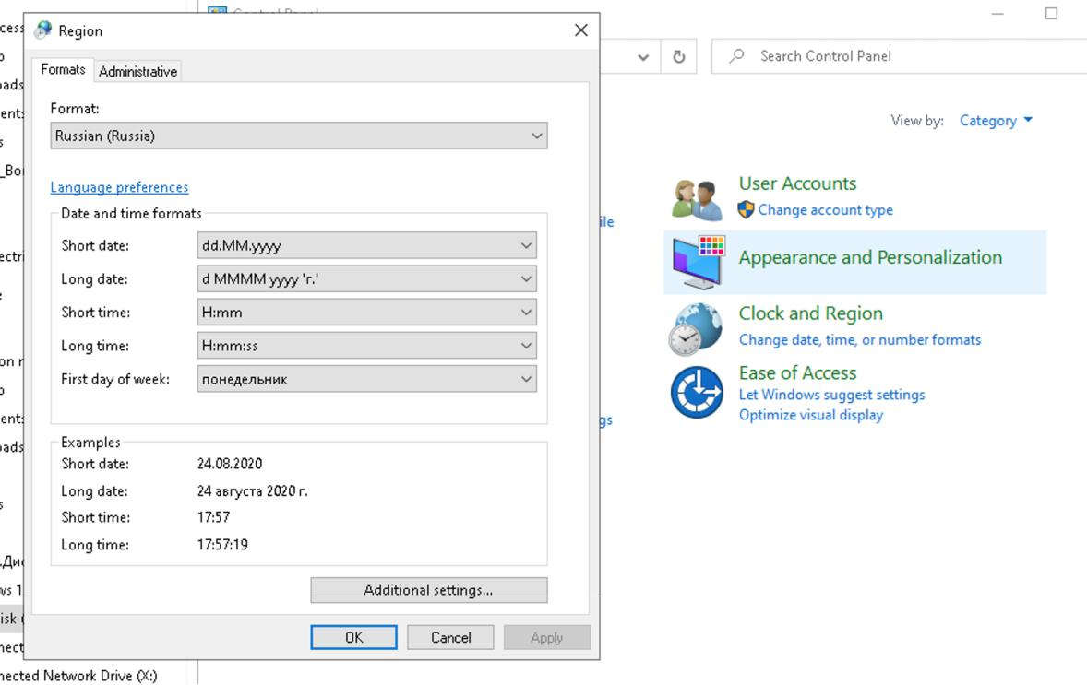

GARAPMR =

(DESCRIPTION =

(ADDRESS_LIST =

(ADDRESS =

(PROTOCOL = TCP)

(HOST = 217.19.209.223)

(PORT = 1521)

)

)

(CONNECT_DATA =

(SERVICE_NAME = orcl)

)

)

GARA=

(DESCRIPTION =

(ADDRESS = (PROTOCOL = TCP)(HOST = 192.168.0.24)(PORT = 1521)) (CONNECT_DATA =

(SERVER = DEDICATED)

(SERVICE_NAME = cloudbd.world)

)

)

subst I: \\192.168.0.21\Docs

